**Lab 6: Decoders**

Freddie Boadu

ECEN 328

Mansi Bhavsar

April 3, 2019

Introduction: For this lab report, the student learned how to make and use decoders in the Xilinx Schematic design program. The student learned the important of a 2 to 4 decoder. For a full decoder, there is an output for each combination. For the data inputs, there are n number of outputs or 2n. A partial decoder has less than that.

This is an example of decoder with 2 inputs: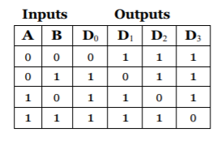

**Materials:**

* Xilinx ISE software, student or professional edition V14.7
* PC with Pentium III or higher, 128+ MB RAM and 8+ GB hard drive
* Digilent Basys2 board with an XC3S100E device.

**Methods:**

The student was asked to create a new project. The project is named DECO2-4. The student was asked to create a decoder based of the image in the introduction. That schematic will be labeled in the data of this report. The schematic is based around the equation: 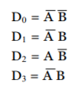 and this used to make the schematic for the first and only part of this lab.

**Data:**

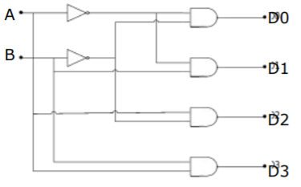

Schematic section 1



Truth table for section 1

**Results and discussion:** The schematic held true. We were able to depict a decoder with an active low on our boards. The student using this knowledge will be able to complete the design challenge.

**Design Challenge:**

The design challenge required the students to make a decoder with an enable. This was the result of that:

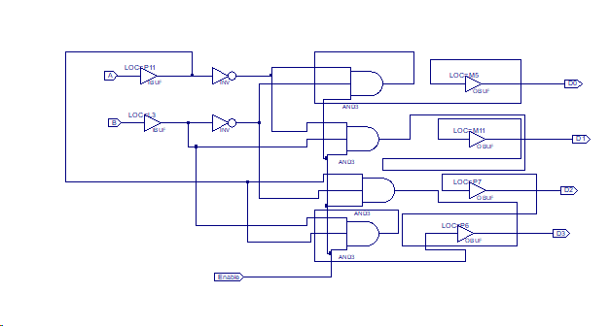

**Conclusion:**

The experiment above shows that use and important of decoders. The experiment got students comfortable with using decoders and their applications on the board.